Experiment 07
1. create table BANK_0017(BANKNAME varchar(50),HEADOFFICE varchar(50),BRANCH varchar(50),BRANCHCODE int);
insert into BANK_0017 values('SBI','Mumbai','Kottayam',101);
commit;
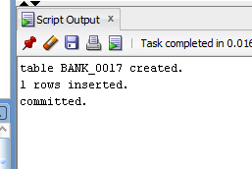
2. insert into BANK_0017 values('HDFC','Mumbai','Pala',102);
savepoint Q1;
insert into BANK_0017 values('ICICI','Delhi','Kochi',103);
savepoint Q2;
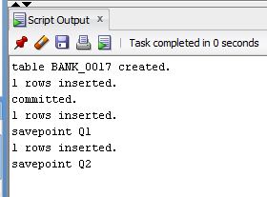

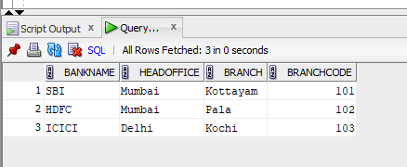
rollback to Q1;
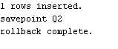
select * from BANK_0017;
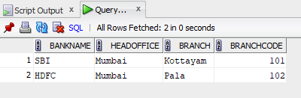

3. insert into BANK_0017 values('Alex.INC','PALA','KOTTAYAM',104);
savepoint Q3;
insert into BANK_0017 values('Alwin.INC','THAGANA','CHANGANACHERRY',105);
savepoint Q4;
insert into BANK_0017 values('DAVIS.INC','PALLIKATHODU','THIRUVALLA',106);
savepoint Q5;
commit;
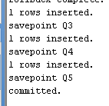
select * from BANK_0017;
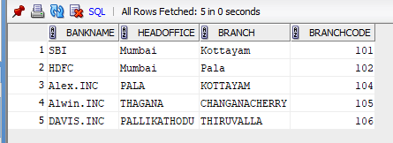
insert into BANK_0017 values('ABHISHEK.INC','KATTAPANA','IDUKKI',107);
savepoint Q6;
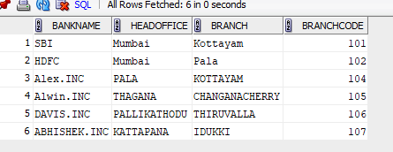
1a. rollback
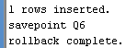
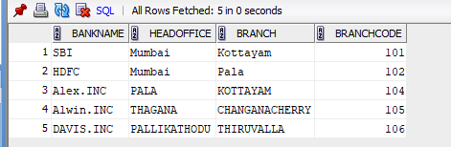

insert into BANK_0017 values('Abhijith.INC','KALLARA','KOTTAYAM',108);
savepoint Q7;
insert into BANK_0017 values('AMAL.INC','KANJIRAPALLY','KOTTAYAM',109);
savepoint Q8;
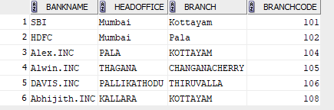
rollback to Q7;


GRAND AND REVOKE
